Cross-site scripting (XSS)
# Source: AI Source: Provided by: [Data Path: Persons Table -> ID Column: 1, Name_En Column: Motasem Essam] -> From: [Chatgpt (GPT‑5 Mini)] on [1/20/2026]
Cross-site scripting (XSS) is a type of security vulnerability typically found in web applications, where an attacker injects malicious scripts (usually JavaScript) into content that is then served to other users. When unsuspecting users view the infected content, the malicious script runs in their browser as if it came from a trusted source.

Types of XSS
# Source: AI Source: Provided by: [Data Path: Persons Table -> ID Column: 1, Name_En Column: Motasem Essam] -> From: [Chatgpt (GPT‑5 Mini)] on [1/20/2026]
- Stored XSS
  - The malicious script is permanently stored on the server (e.g., in a database, comment field).
  - Triggered when a user views the page with the stored input.
- Reflected XSS
  - The malicious script is reflected off a web server, such as in a search result or error message.
  - It is delivered via URL or form and executed when a user clicks a crafted link.
- DOM-based XSS
  - The vulnerability exists in client-side scripts that modify the page based on user input without proper sanitization.
  - It doesn’t involve the server directly.

Stored XSS
# Source: AI Source: Provided by: [Data Path: Persons Table -> ID Column: 1, Name_En Column: Motasem Essam] -> From: [Chatgpt (GPT‑5 Mini)] on [1/20/2026]
Stored XSS, also known as persistent XSS, occurs when malicious input is permanently stored on the target server, such as in a database, and then displayed on pages viewed by other users without proper sanitization or encoding.

💡 Example Scenario:
Let’s say you have a blog site where users can comment on articles. The comment form doesn't sanitize input before storing it in a database.

📝 Vulnerable Code (Server-side PHP + MySQL Example)
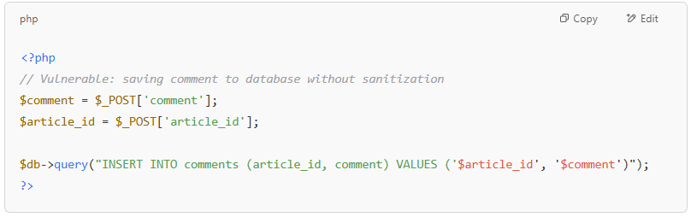
<?php
// Vulnerable: saving comment to database without sanitization
$comment = $_POST['comment'];
$article_id = $_POST['article_id'];

$db->query("INSERT INTO comments (article_id, comment) VALUES ('$article_id', '$comment')");
?>

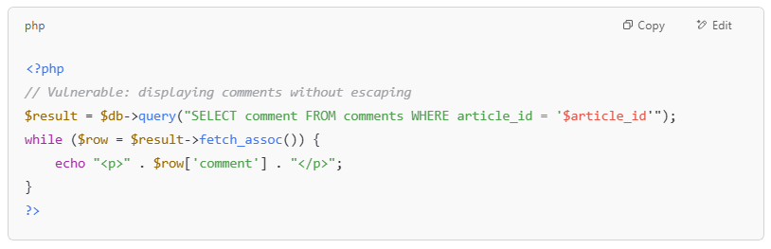
<?php
// Vulnerable: displaying comments without escaping
$result = $db->query("SELECT comment FROM comments WHERE article_id = '$article_id'");
while ($row = $result->fetch_assoc()) {
echo "<p>" . $row['comment'] . "</p>";
}
?>

🧪 Malicious Input
A user submits the following comment:
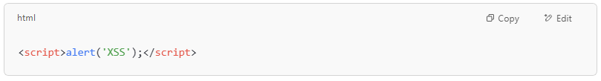
<script>alert('XSS');</script>

🔥 What Happens?
- The script tag is stored in the database.
- Every time someone views the article page, the script executes.
- This could allow the attacker to steal cookies, hijack sessions, or deface the site.
✅ Fix (Sanitize and Encode Output)
Use proper HTML escaping when outputting data:
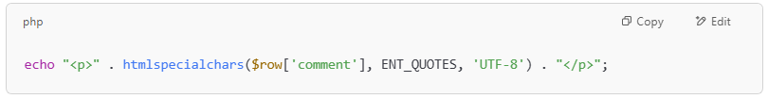
echo "<p>" . htmlspecialchars($row['comment'], ENT_QUOTES, 'UTF-8') . "</p>";

Or use a templating engine that automatically escapes content, like Twig or Blade.

🛡️ Additional Mitigations
- Content Security Policy (CSP)
- Input validation
- Output encoding
- Use frameworks/libraries that auto-escape

Reflected XSS
# Source: AI Source: Provided by: [Data Path: Persons Table -> ID Column: 1, Name_En Column: Motasem Essam] -> From: [Chatgpt (GPT‑5 Mini)] on [1/20/2026]
Reflected XSS occurs when user input is immediately returned by the server in the response, typically via query parameters, form inputs, or headers, without proper sanitization or encoding.
💡 Example Scenario:
A web app has a search feature that displays user input directly on the page.
📝 Vulnerable Code (PHP Example)
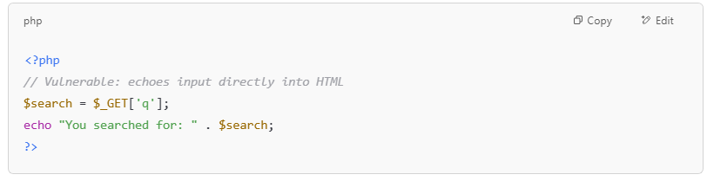
<?php
// Vulnerable: echoes input directly into HTML
$search = $_GET['q'];
echo "You searched for: " . $search;
?>

🧪 Malicious URL:
An attacker sends a user the following crafted link:
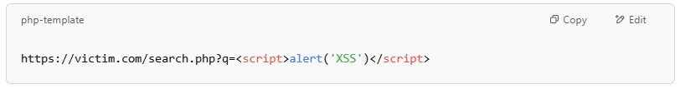
https://victim.com/search.php?q=<script>alert('XSS')</script>

🔥 What Happens?
- The script is reflected in the response:
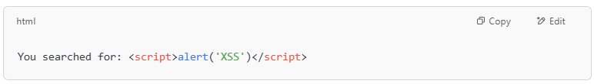
You searched for: <script>alert('XSS')</script>
- The victim opens the link.
- The browser executes the JavaScript, displaying an alert or worse (e.g., cookie theft, redirect to malicious sites).

✅ Fix (Sanitize Output)
Always encode data before rendering it in HTML:
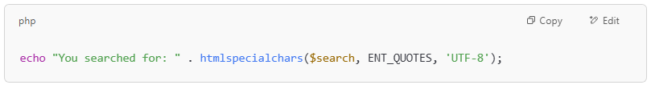
echo "You searched for: " . htmlspecialchars($search, ENT_QUOTES, 'UTF-8');

🛡️ Additional Mitigations
- Use Content Security Policy (CSP)
- Validate and sanitize input
- Escape output properly
- Avoid reflecting user input directly into HTML when unnecessary

Example of Reflected XSS
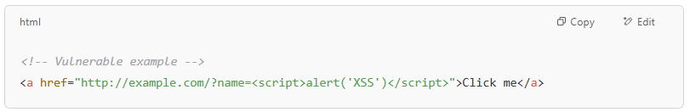

<!-- Vulnerable example -->
<a href="http://example.com/?name=<script>alert('XSS')</script>">Click me</a>

If the application blindly includes name in the page without escaping it, the script will execute.

DOM-based XSS
# Source: AI Source: Provided by: [Data Path: Persons Table -> ID Column: 1, Name_En Column: Motasem Essam] -> From: [Chatgpt (GPT‑5 Mini)] on [1/20/2026]
DOM-based XSS occurs entirely on the client side. It happens when JavaScript reads data from an untrusted source (like document.location, document.referrer, or document.cookie) and writes it to the DOM without proper sanitization, resulting in code execution.

💡 Example Scenario:
You have a web page that reads a URL parameter and writes it to the page using innerHTML.
📝 Vulnerable Code (JavaScript Example)
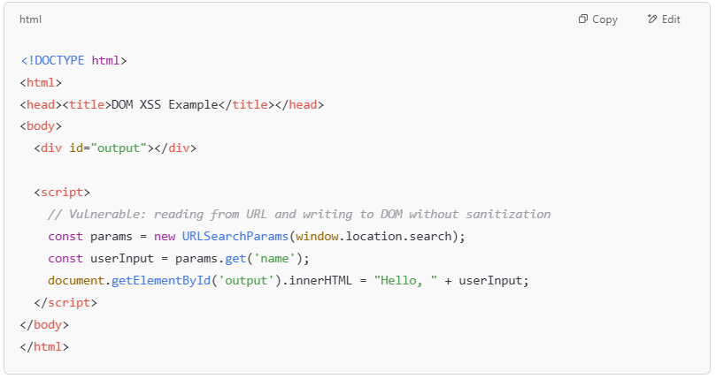
<!DOCTYPE html>
<html>
<head><title>DOM XSS Example</title></head>
<body>
<div id="output"></div>

<script>
// Vulnerable: reading from URL and writing to DOM without sanitization
const params = new URLSearchParams(window.location.search);
const userInput = params.get('name');
document.getElementById('output').innerHTML = "Hello, " + userInput;
</script>
</body>
</html>

🧪 Malicious URL:
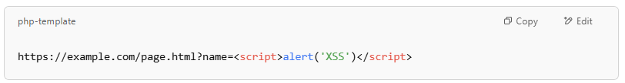

🔥 What Happens?
- The attacker crafts the URL with a <script> tag.
- The browser executes:

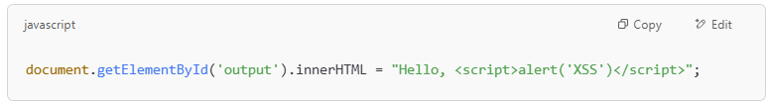
document.getElementById('output').innerHTML = "Hello, <script>alert('XSS')</script>";

- The script runs in the victim’s browser, potentially stealing cookies or session tokens.

✅ Fix (Use Text Content Instead of HTML)
Use textContent or proper DOM APIs to insert data safely:
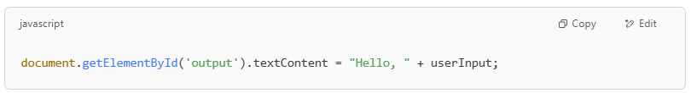
document.getElementById('output').textContent = "Hello, " + userInput;

This ensures the string is treated as text, not HTML.

🛡️ Additional Mitigations

- void using innerHTML with untrusted input.
- Use frameworks like React, Angular, or Vue that handle DOM updates safely.
- Implement a strong Content Security Policy (CSP).
- Sanitize inputs when HTML insertion is necessary (e.g., with DOMPurify).

Why XSS is Dangerous
# Source: AI Source: Provided by: [Data Path: Persons Table -> ID Column: 1, Name_En Column: Motasem Essam] -> From: [Chatgpt (GPT‑5 Mini)] on [1/20/2026]

- Can steal cookies and session tokens
- Redirect users to malicious sites
- Modify content on the web page
- Launch phishing attacks or install malware

How to Prevent XSS
# Source: AI Source: Provided by: [Data Path: Persons Table -> ID Column: 1, Name_En Column: Motasem Essam] -> From: [Chatgpt (GPT‑5 Mini)] on [1/20/2026]
- Escape output (especially HTML, JavaScript, and attributes)
- Validate and sanitize user input
- Use frameworks that automatically escape (like React, Angular)
- Set Content Security Policy (CSP)
- Avoid innerHTML or similar unsafe DOM methods

